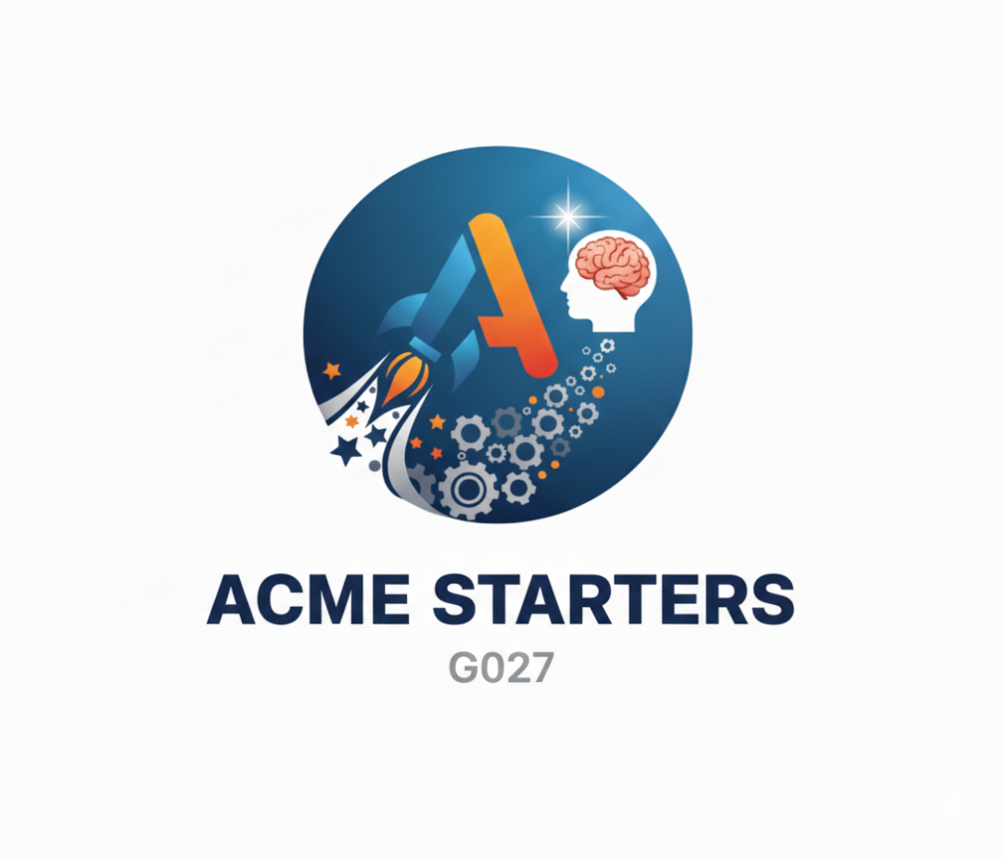

ANALYSIS REPORT
Repository: https://github.com/jesrammar/Acme-Starters-B
April 24th, 2026
Content Table
1. Introduction 3
2. Revision Table 3
3. Contents 3
3.1. Information Requirements 3
3.2. Functional Requirements 3
3.3. Non-Functional Requirements 4
3.4. Testing Requirements 4
4. Preliminary Questions for Lecturers 4
5. UML Data Model (Preliminary) 4

1. Introduction
This document provides a systematic specification of the requirements for the project Acme-Starters-B, extending the previous Level C functionality. It includes functional and non-functional requirements, data model constraints, and preliminary analysis questions.

2. Revision Table
Revision number | Date | Description
1 | 17/04/2026 | The report was created
2 | 24/04/2026 | The report was completed

3. Contents

3.1. Information Requirements
**Entity** | **Attributes**
Manager | position, skills, executive
Project | title, keyWords, description, kickOffMoment, closeOutMoment, draftMode
AdBanner | slogan, targetUrl, picture

List of Constraints:
- Constraint 1: Project.kickOffMeeting < Min(Component.startDate).
- Constraint 2: Project.closeOutMeeting > Max(Component.endDate).
- Constraint 3: Project.kickOffMeeting < Project.closeOutMeeting.
- Constraint 4: If Project.draftMode is set to false, kickOffMeeting and closeOutMeeting must be future.
- Constraint 5: Component -> Project is N:1 (a component cannot be on several projects).
- Constraint 6: A project requires count(Inventions) >= 1 to be published.
- Constraint 7: Non-published project components and data is only visible to the Manager and the assigned project members.
- Constraint 8: AdBanners must be as little intrusive as possible.

3.2. Functional Requirements
FR-B1: Manager Management. The system must allow managers to register and manage their profiles.
FR-B2: Project Administration. Managers can create projects and assign members (Inventors, Spokespeople, Fundraisers).
FR-B3: Component Integration. Project members can add inventions, campaigns, and strategies to their assigned projects.
FR-B4: Cascaded Publication. When a Manager publishes a project, all its components (inventions, etc.) must be automatically marked as published.
FR-B5: Dashboard Metrics. Real-time calculation of project counts, deviations, and effort in Person-Months (PM).

3.3. Non-Functional Requirements
NFR-1: Usability. Ad banners must be displayed as non-intrusively as possible, ensuring they do not interrupt the user's primary navigation flow.
NFR-2: Security. Only the Administrator role is authorized to create, edit, or delete AdBanners.
NFR-3: Data Integrity. Project publication must be an atomic operation; if the publication of any project component fails, the project must not remain in "published" status.

3.4. Testing Requirements
TR-1: Functional Testing. Verify that a Manager cannot assign project members who do not hold the specific roles of Inventor, Spokesperson, or Fundraiser.
TR-2: Business Rule Testing. Attempt to publish a project with zero inventions and confirm that the system triggers a validation error.
TR-3: Automated Testing. Automated generation of coverage reports and execution of the test suite via Continuous Integration tools, including a mandatory Lint report.

4. Preliminary Questions for Lecturers
Regarding B/2(Components and Projects): Could a component be assigned to different projects? Answer: No
Regarding B/3 (Indicators): How should the metrics be calculated. Answer: JPQL Queries
Regarding B/4 (Sponsors/Auditors): Can a sponsor attach multiple sponsorships to the same published project? Answer: Yes

5. UML Data Model (Preliminary)
[Note: The UML diagram must be updated in the final version of this report]

